Data
- images, quotes & screenshots of articles.

The data is organized as follows:

- Lindsey Graham own communication from
  - Official campaign site (lindseygraham.com)
    - Slogans, text & images
  - Official social media accounts (Facebook & Twitter)
  - Body language on debates (CNN undercard 15 th. Dec 2015)
- Media on Lindsey Graham
  - Articles, comments

The complete list of data used in the analysis is to be found in the paper itself (endnote bibliography).

- From Lindsey Graham campaign site:
http://www.lindseygraham.com/

Message in slogan

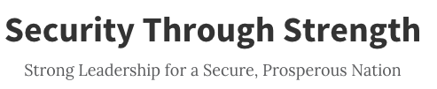

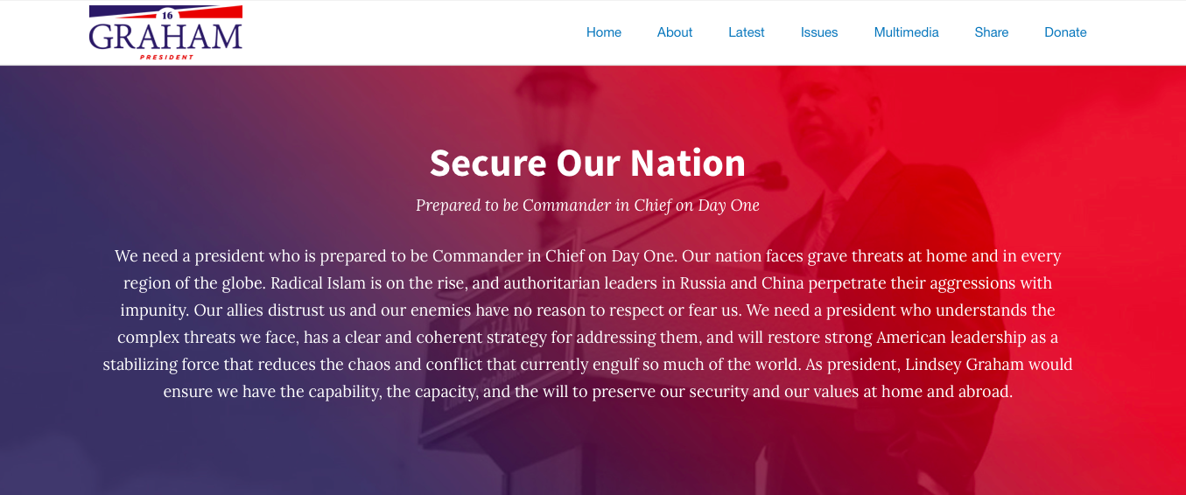

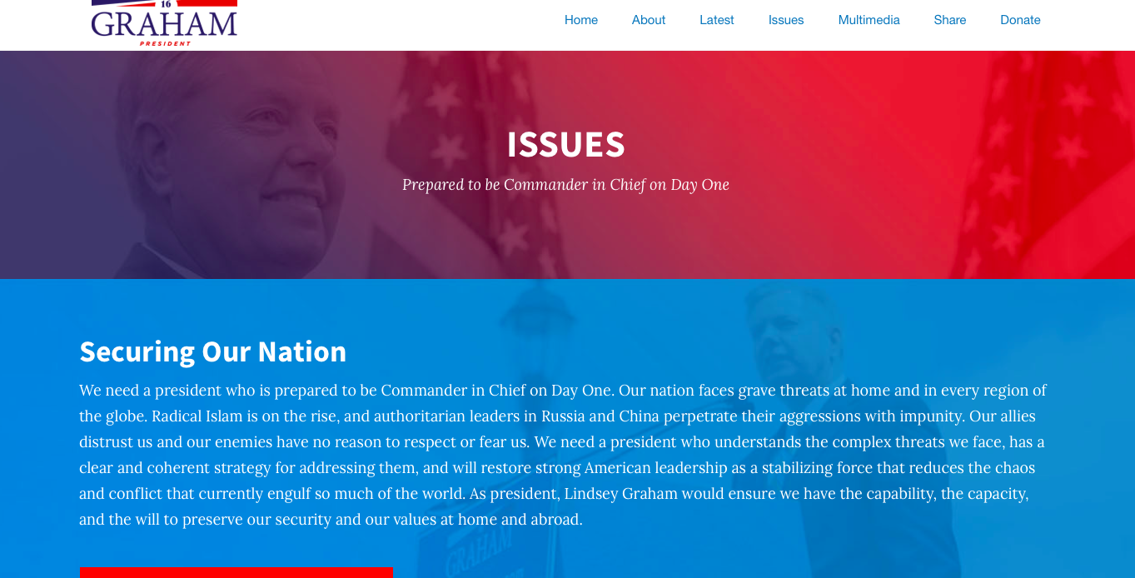

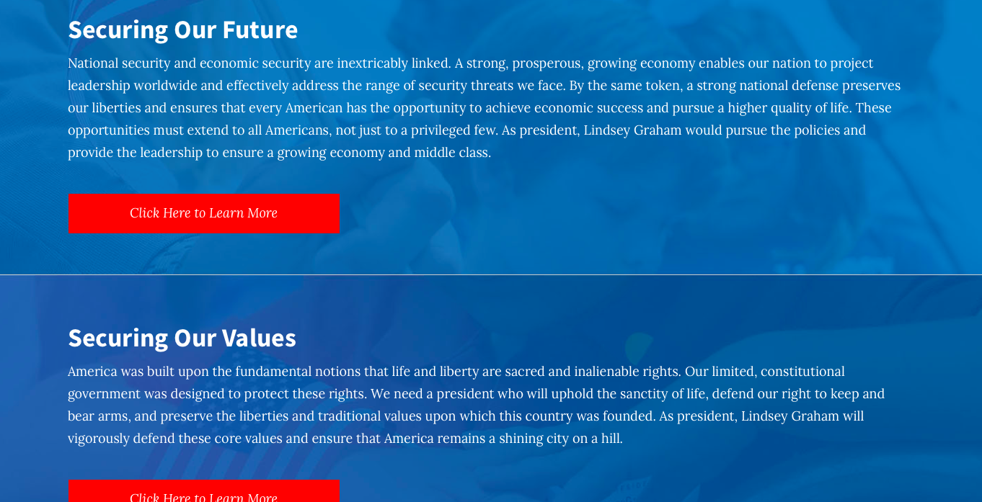

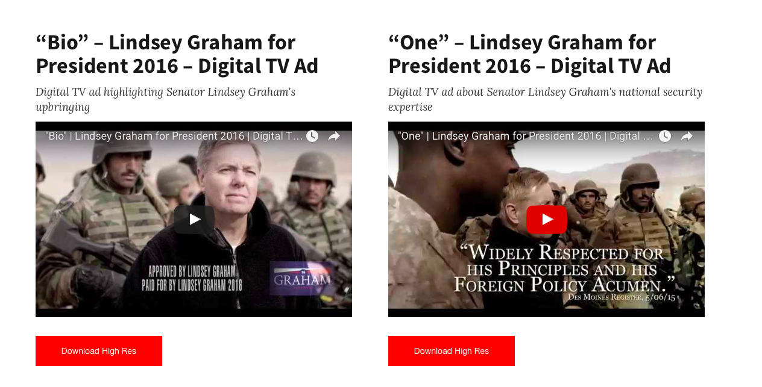

Personal Characteristic

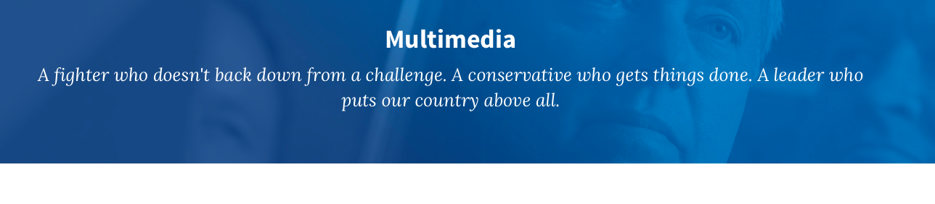
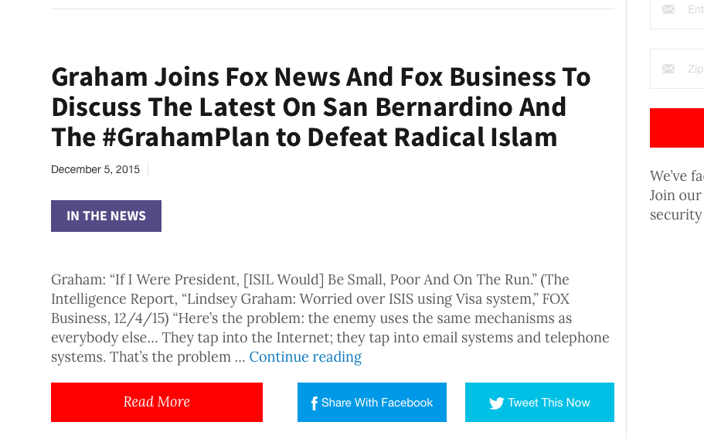

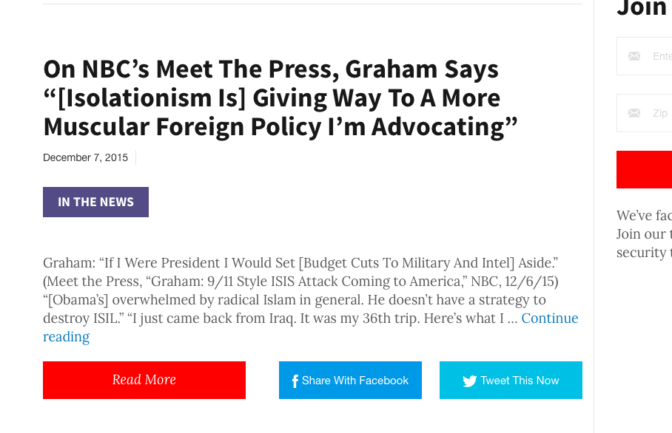
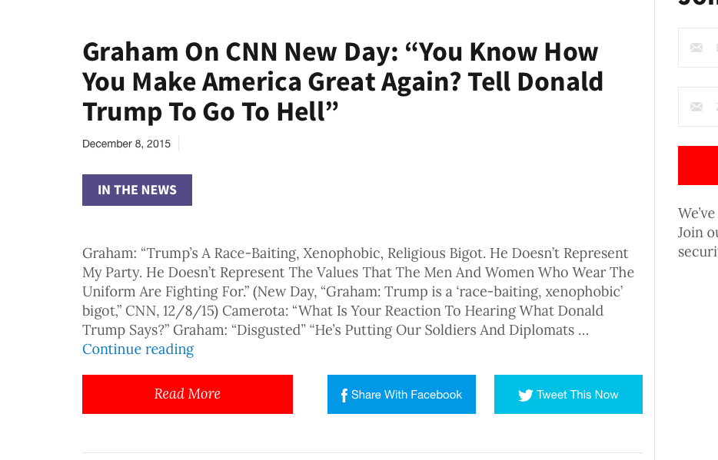
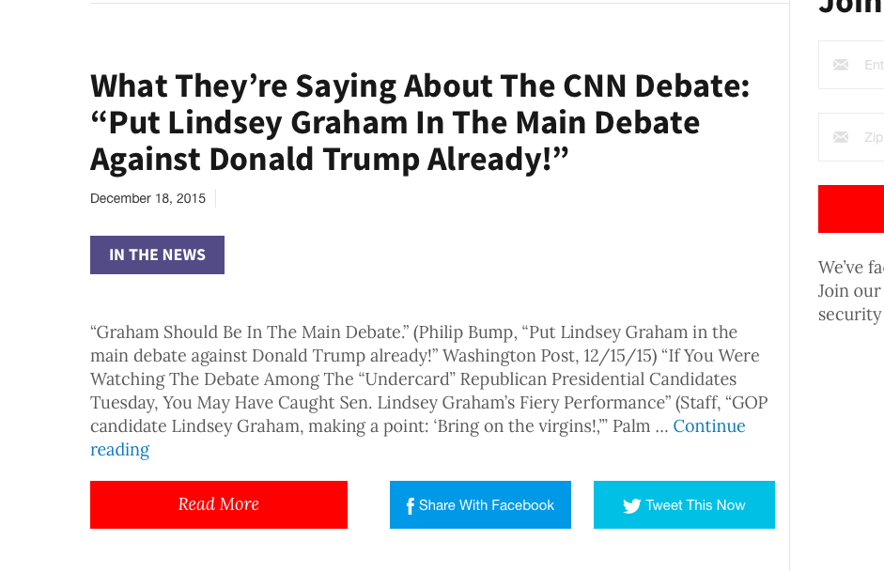

      - Facebook Promotion

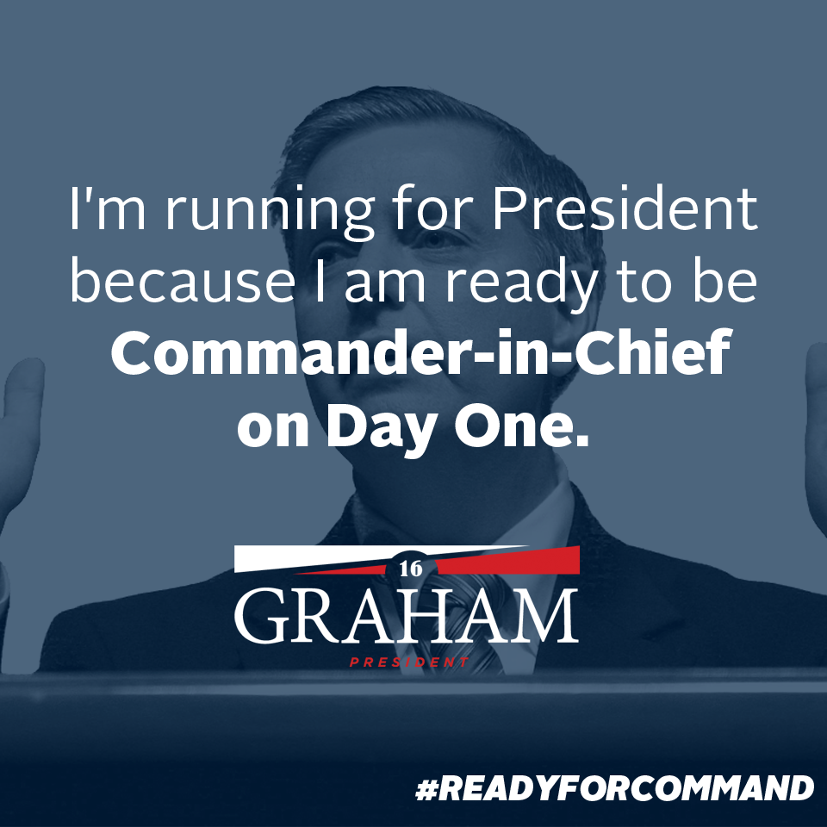

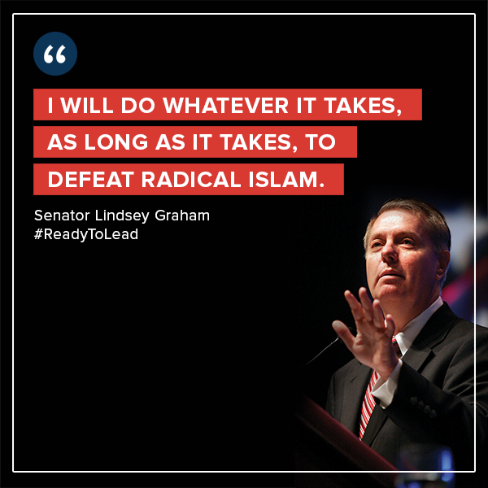

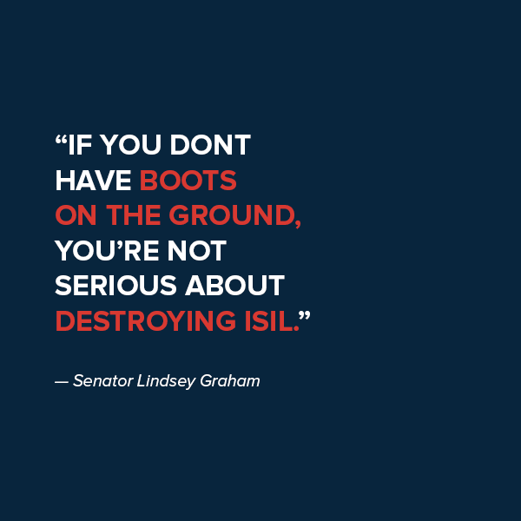

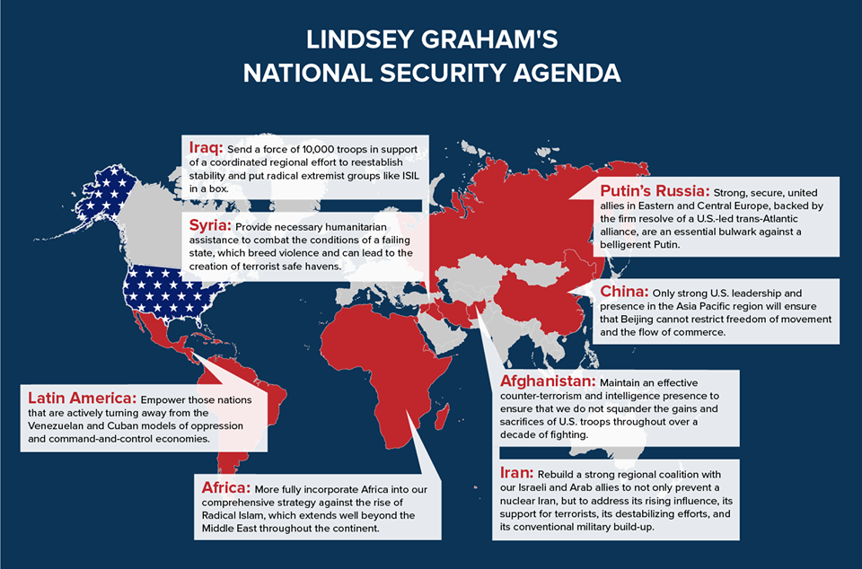

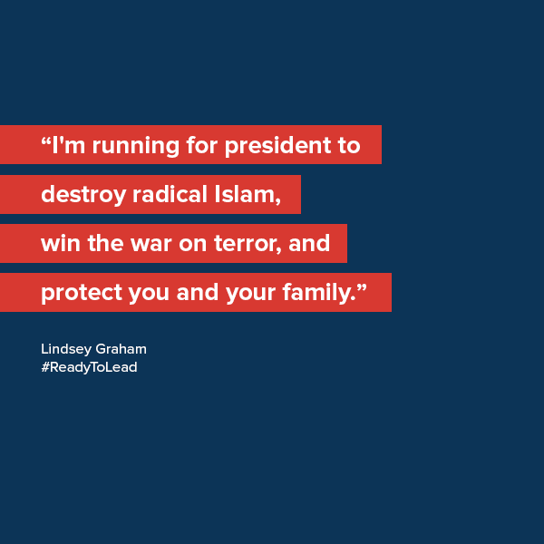

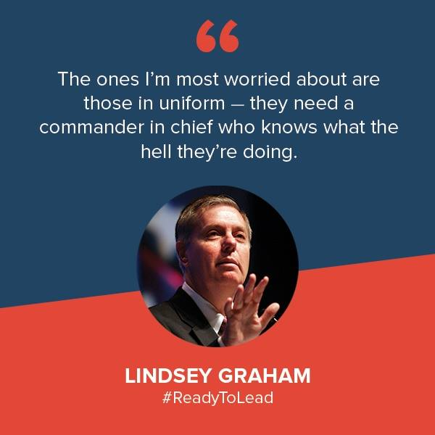

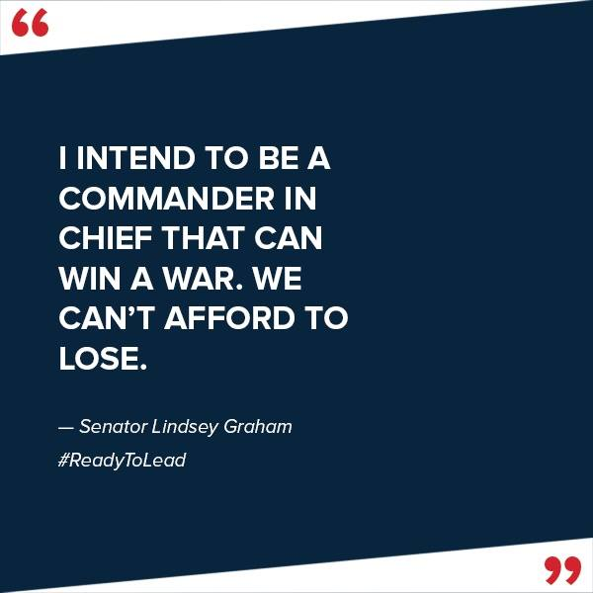

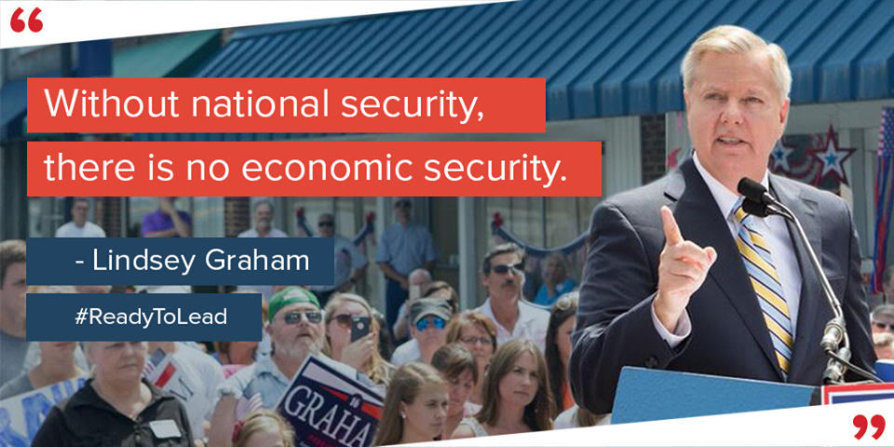

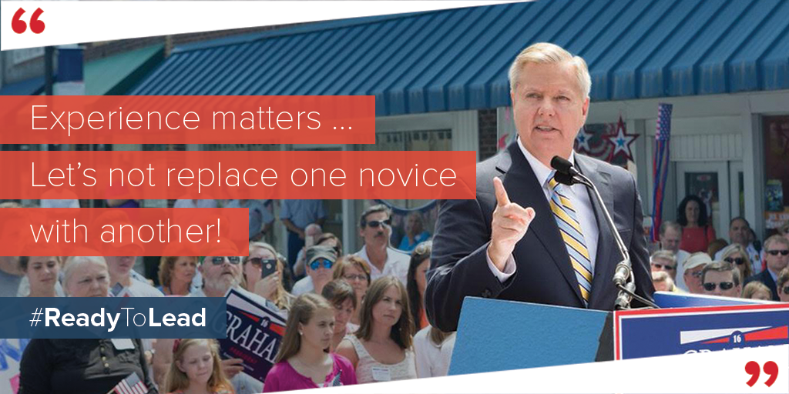

  - Twitter Activity

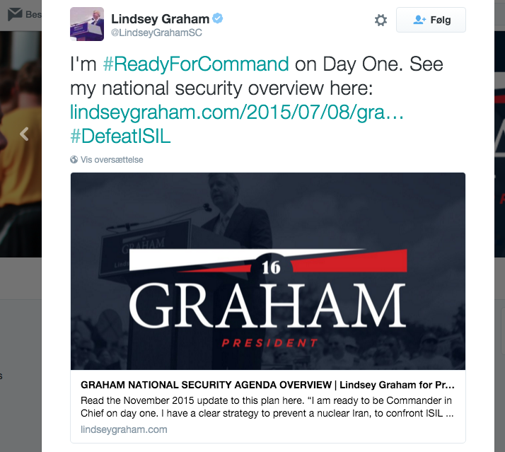

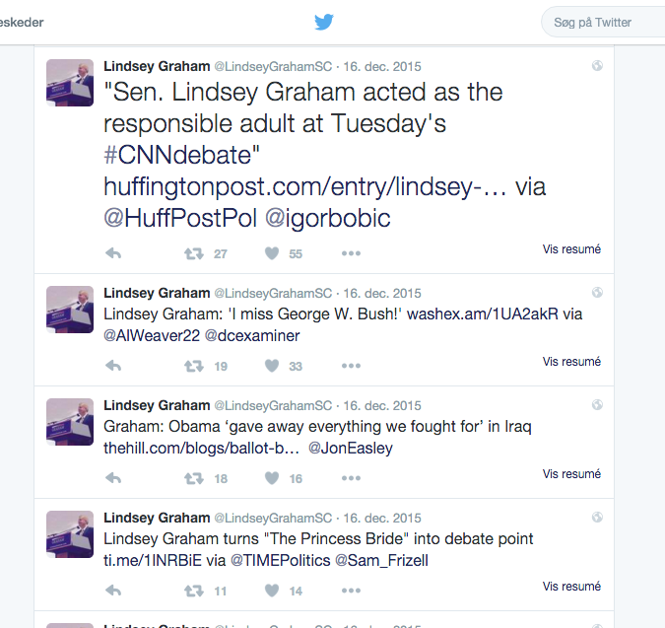

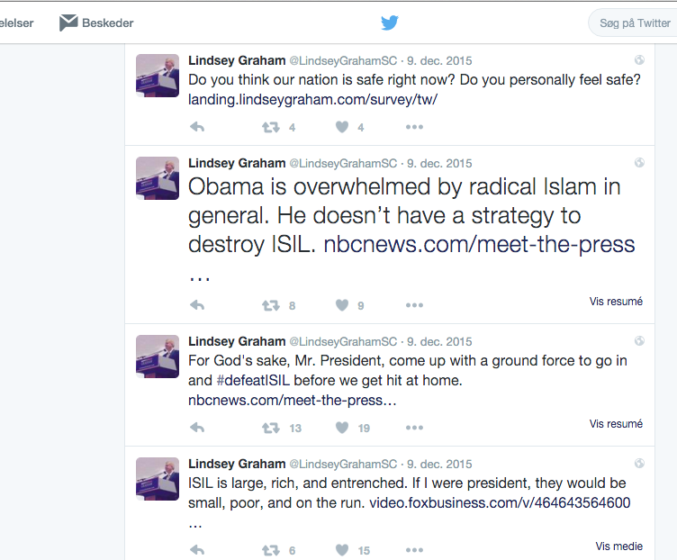

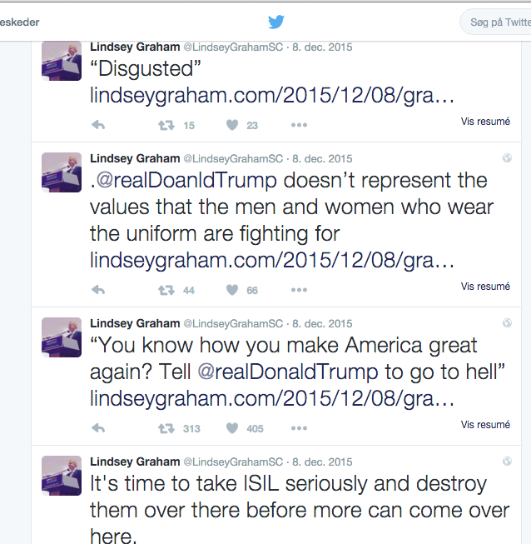

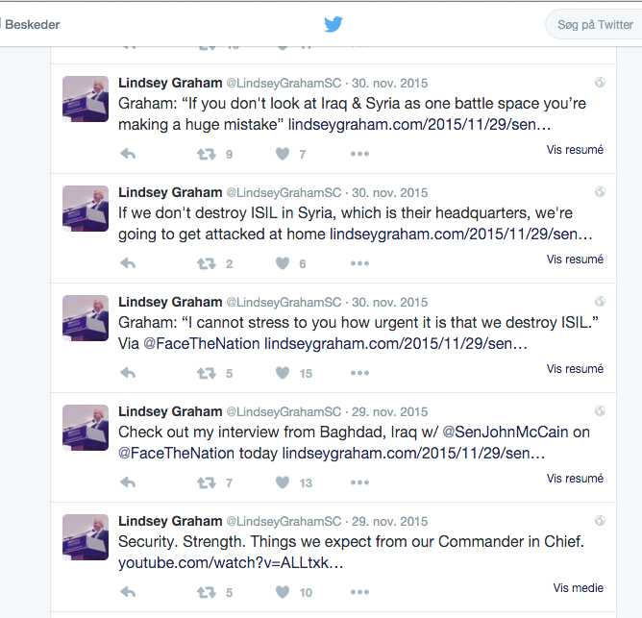

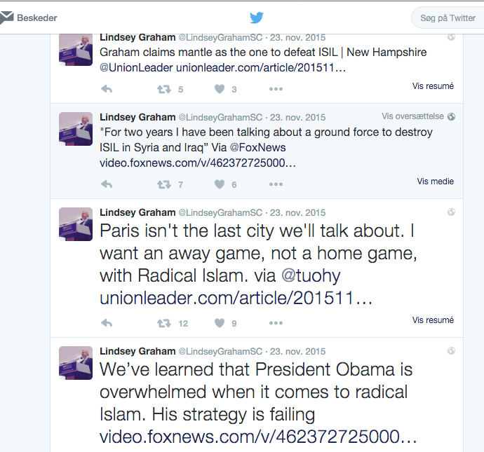

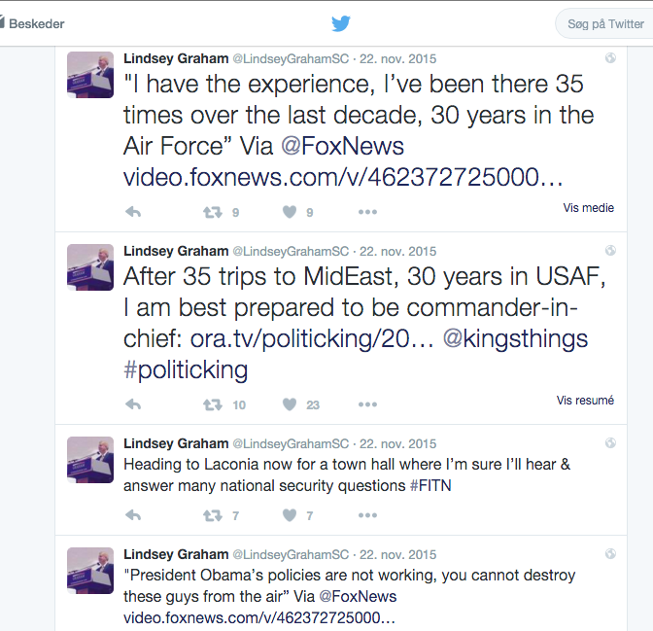

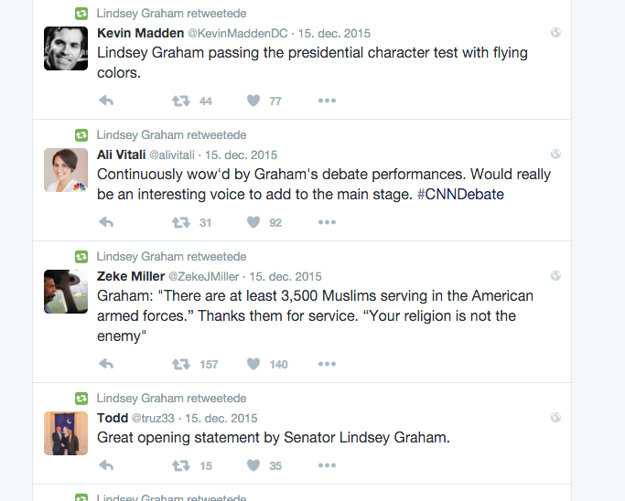

Communicated Body Language

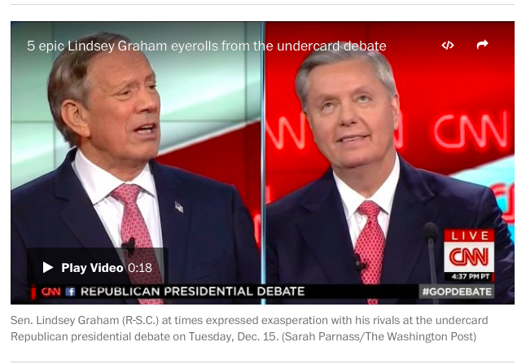

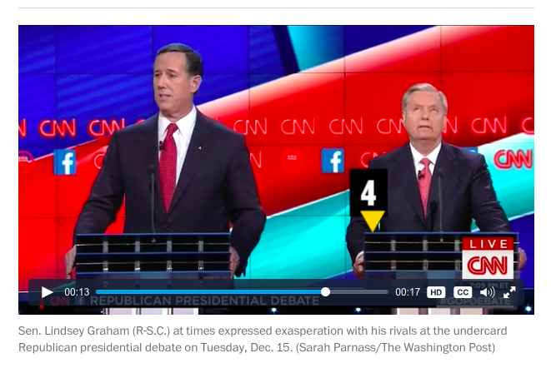

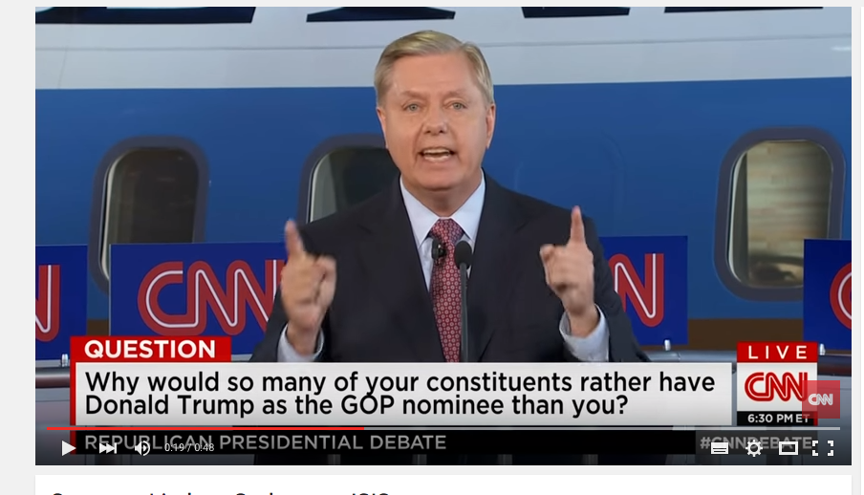

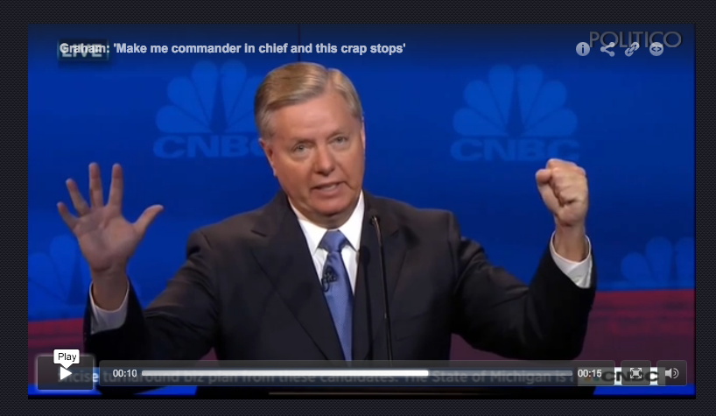

“So to the Chinese. When it comes to dealing with me, you’ve got a clenched fist or an open hand. You pick. The party’s over to all the dictators. Make me commander-in-chief and this crap stops.”

Lindsey Graham: 'Make me commander in chief and this crap stops' (2015, October 28). Retrieved January 14, 2016, from http://www.politico.com/video/2015/10/lindsey-graham-make-me-commander-in-chief-and-this-crap-stops-030899

2. Media on Lindsey Graham and his political message and rhetorical performance

Huffington Post

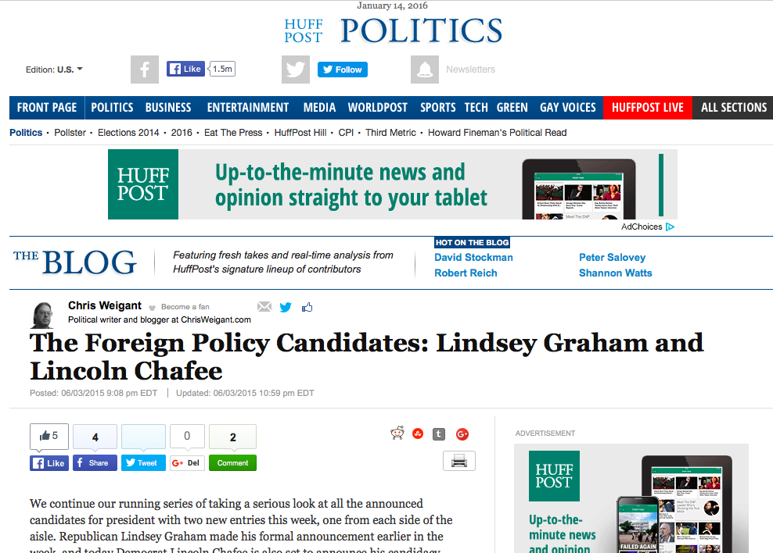

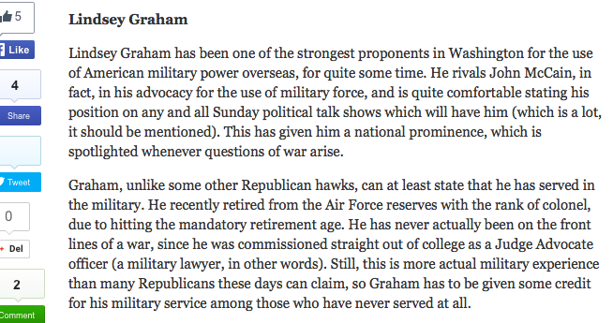

Weigant, C. (2015, June 3). The Foreign Policy Candidates: Lindsey Graham and Lincoln Chafee. Retrieved January 4, 2016, from http://www.huffingtonpost.com/chris-weigant/the-foreign-policy-candid_b_7507252.html

Huffington Post

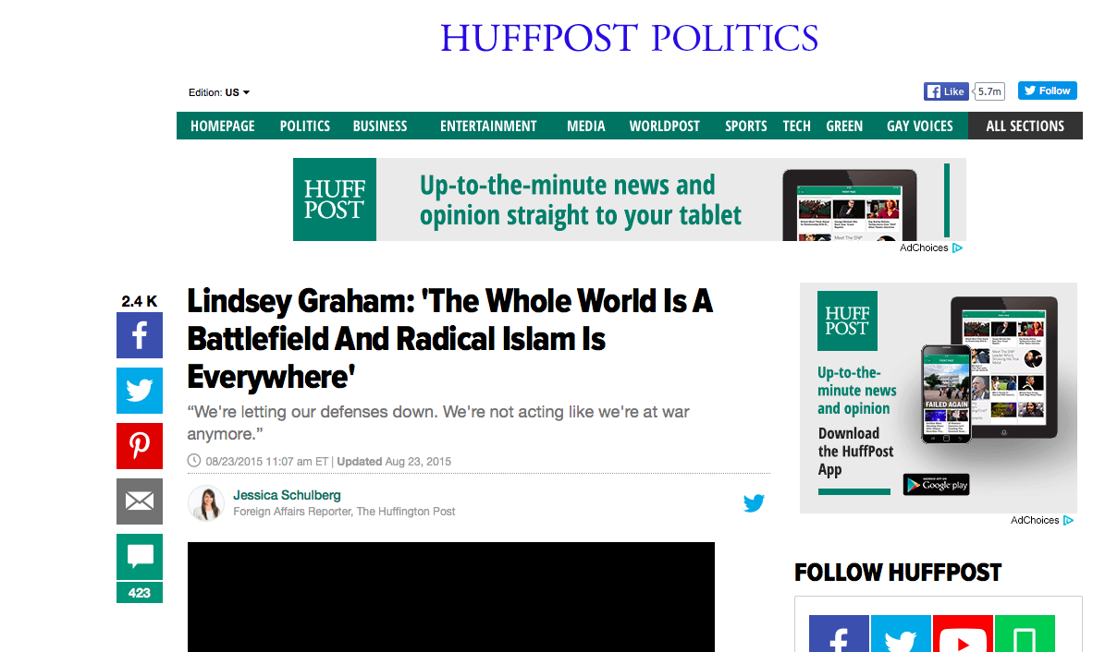

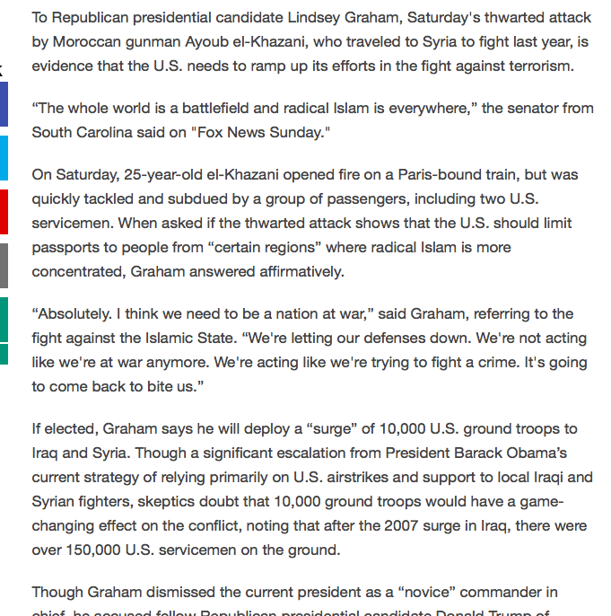

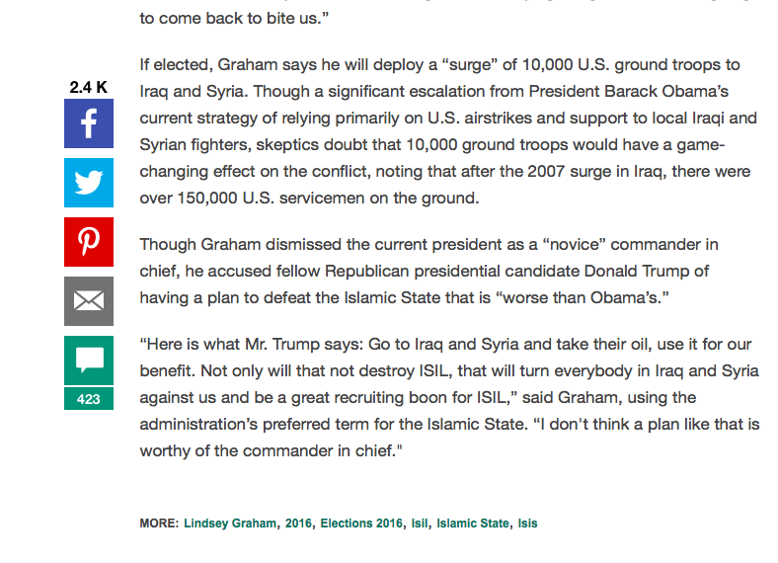

Schulberg, J. (2015, August 23). Lindsey Graham: 'The Whole World Is A Battlefield And Radical Islam Is Everywhere' Retrieved January 12, 2016, from http://www.huffingtonpost.com/entry/lindsey-graham-radical-islam_55d9d6a4e4b0a40aa3ab386e?utm_hp_ref=lindsey-graham

CNN

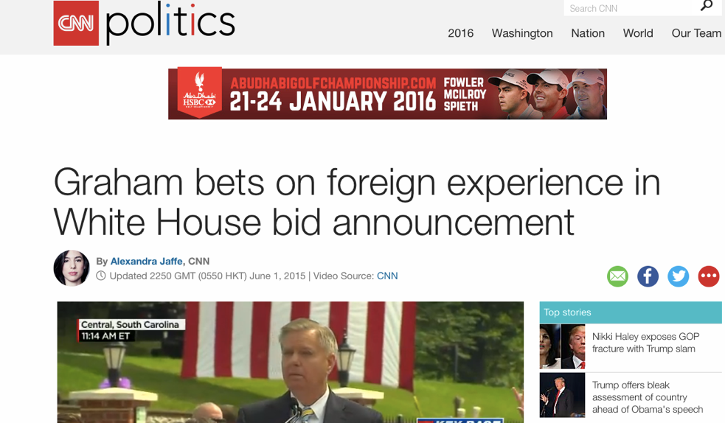

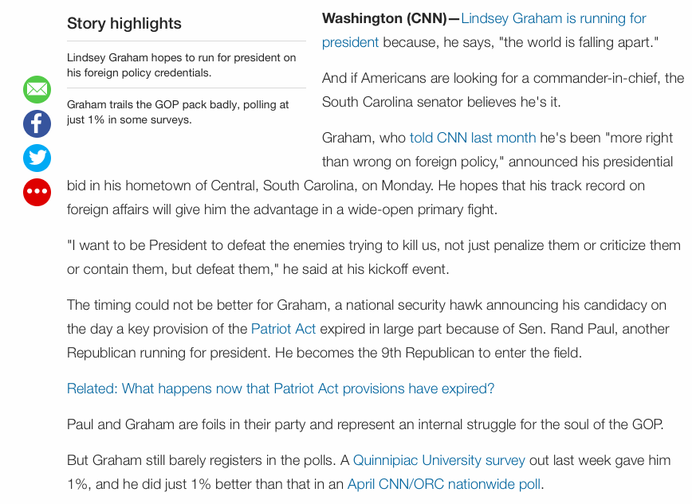

Jaffe, A. (2015, June 1). Lindsey Graham presidential bid bets on foreign policy - CNNPolitics.com. Retrieved January 13, 2016, from http://edition.cnn.com/2015/06/01/politics/lindsey-graham-presidential-announcement-election-2016/

The Hill
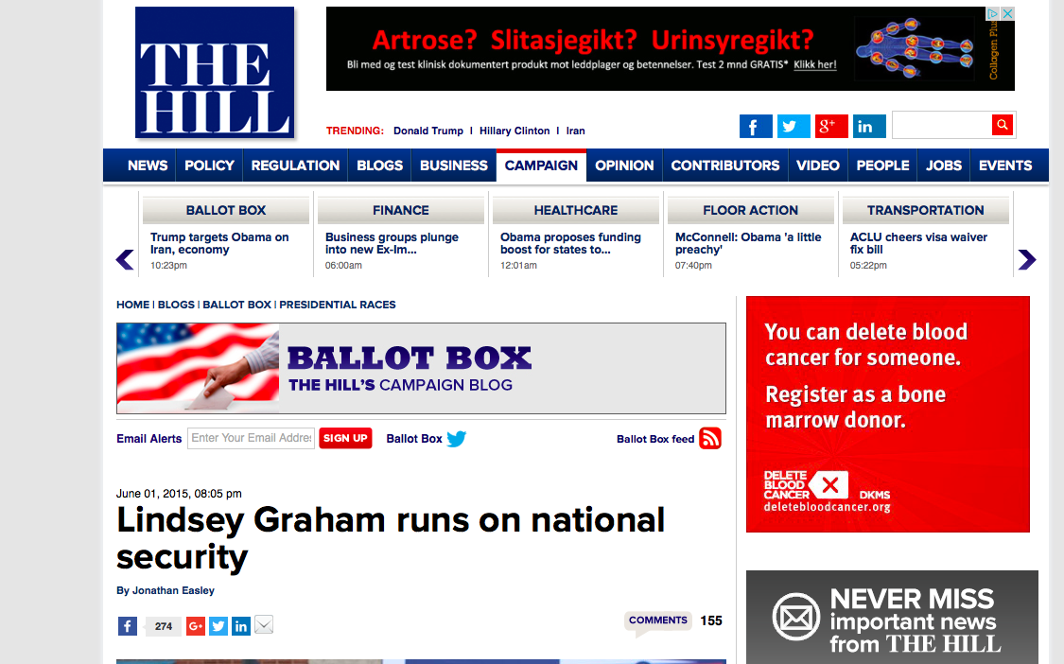

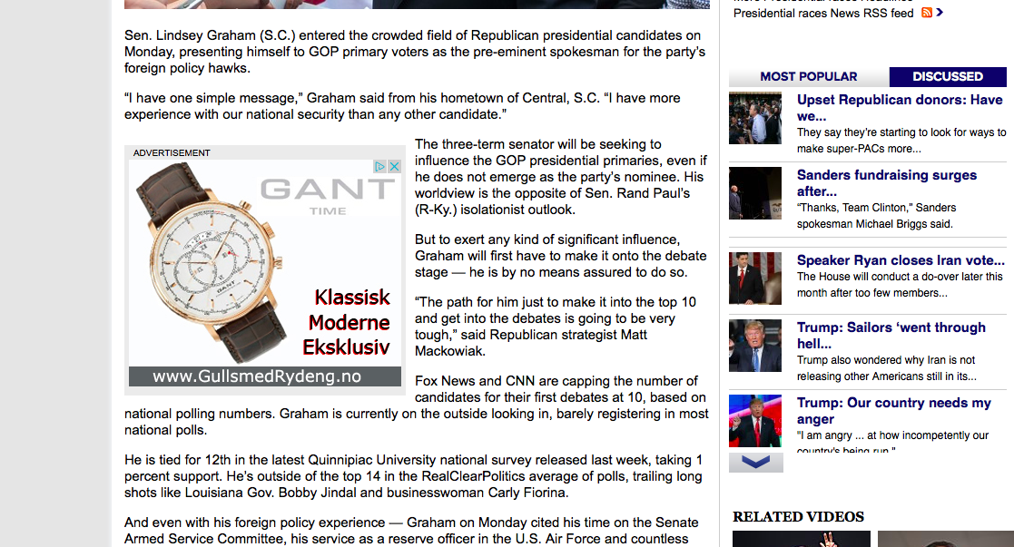

Easley, J. (2015, June 1). Lindsey Graham runs on national security. Retrieved January 6, 2016, from http://thehill.com/blogs/ballot-box/presidential-races/243699-graham-runs-on-national-security

Washington Post

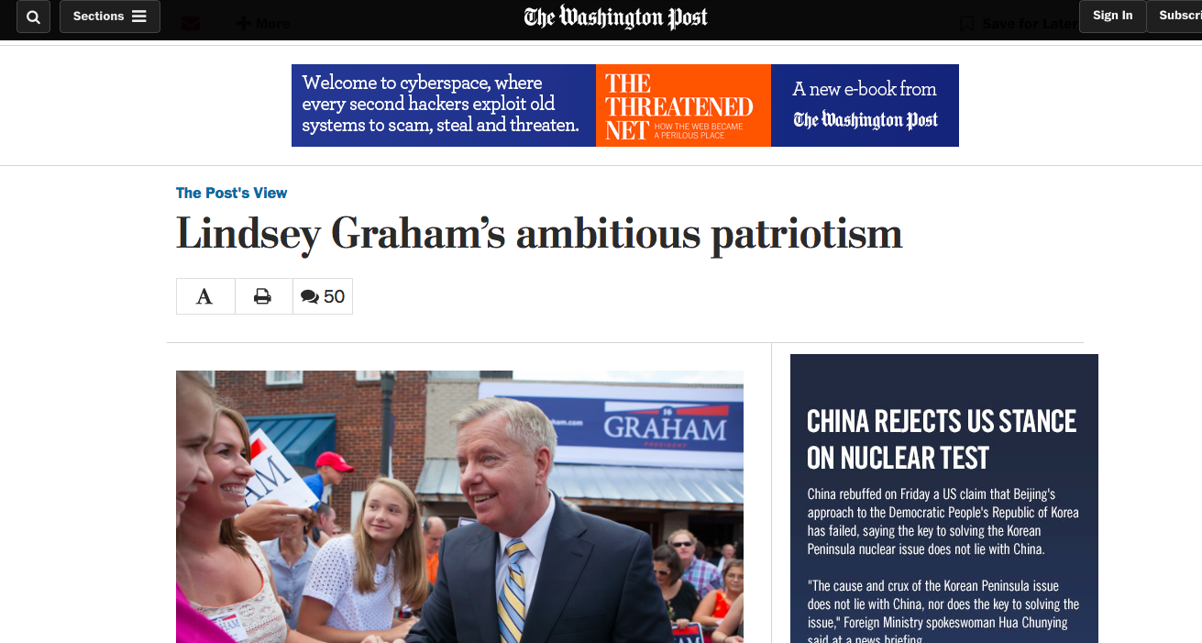

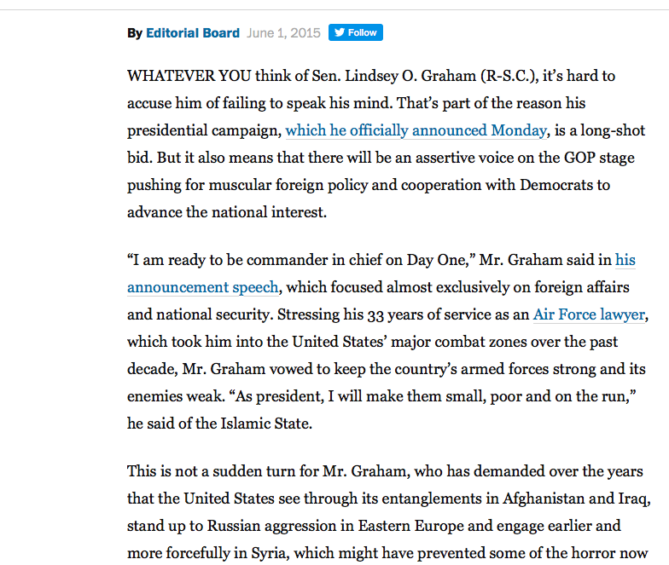

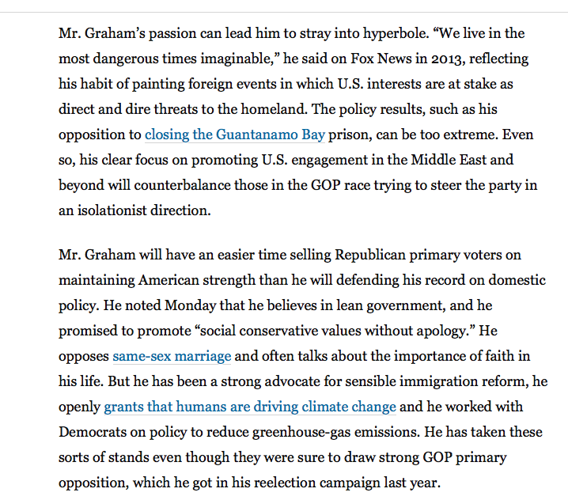

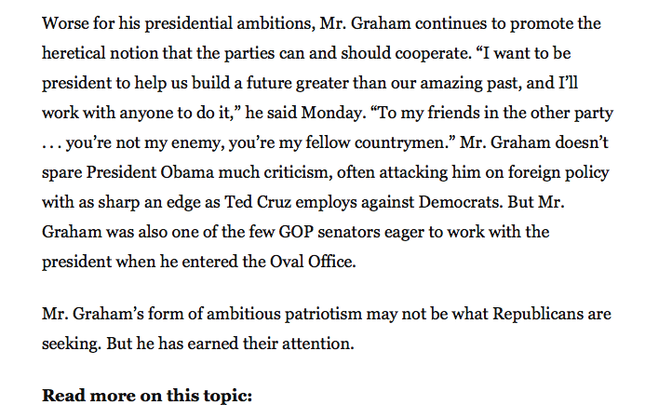

Lindsey Graham's ambitious patriotism. (2015, June 1). Retrieved January 11, 2016, from https://www.washingtonpost.com/opinions/a-call-for-team-building/2015/06/01/91405ad2-0894-11e5-95fd-d580f1c5d44e_story.html

Washington Post

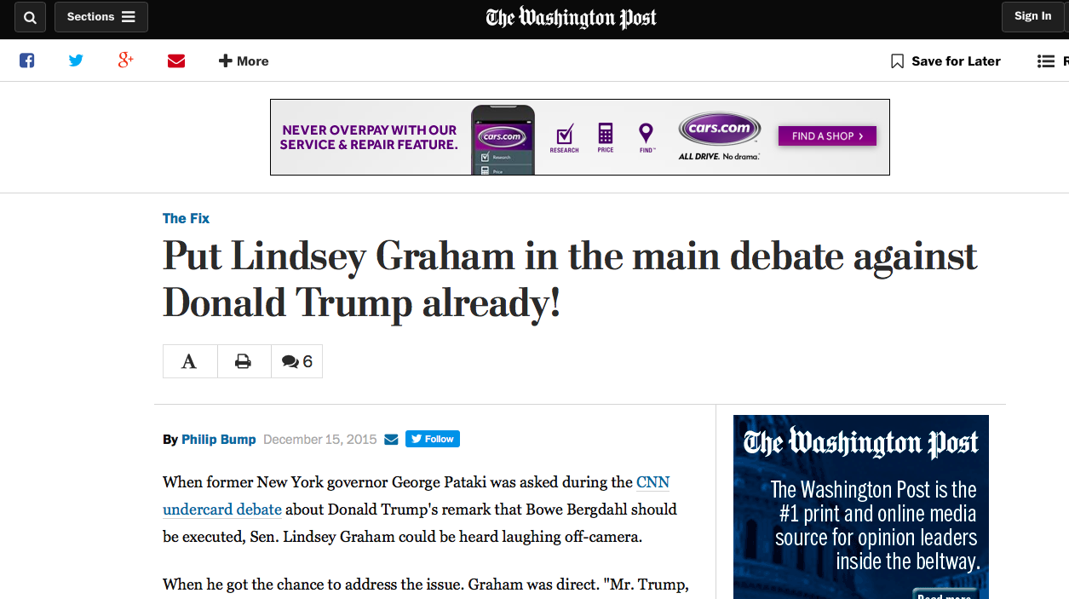

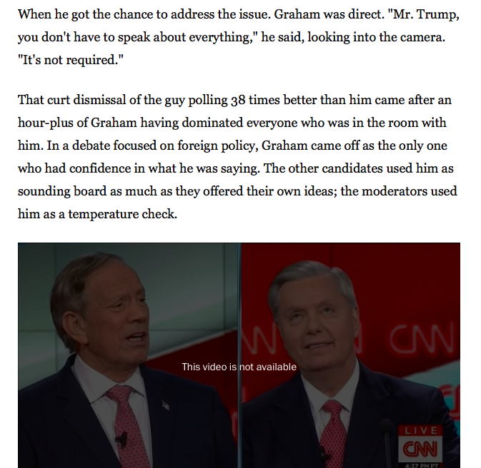

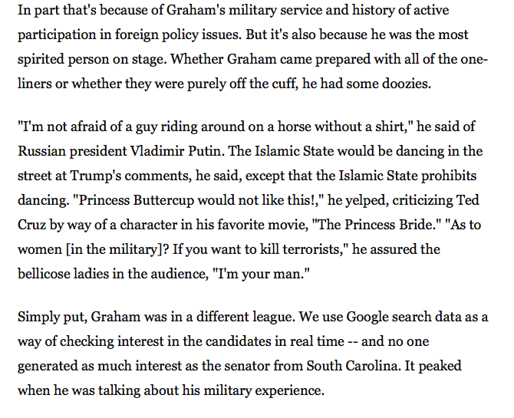

Bump, P. (2015, December 15). Put Lindsey Graham in the main debate against Donald Trump already! Retrieved January 4, 2016, from https://www.washingtonpost.com/news/the-fix/wp/2015/12/15/put-lindsey-graham-in-the-main-debate-against-donald-trump-already/

The State

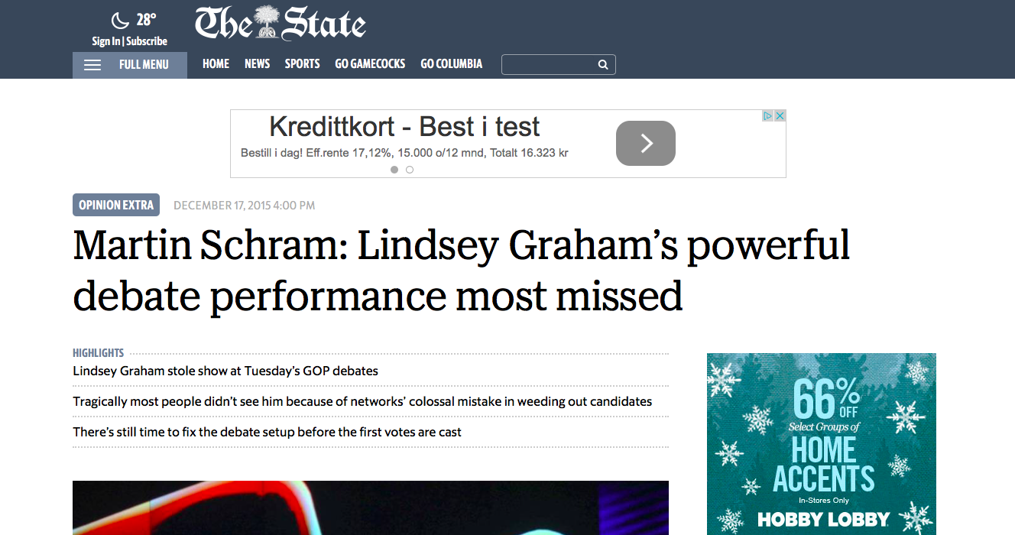

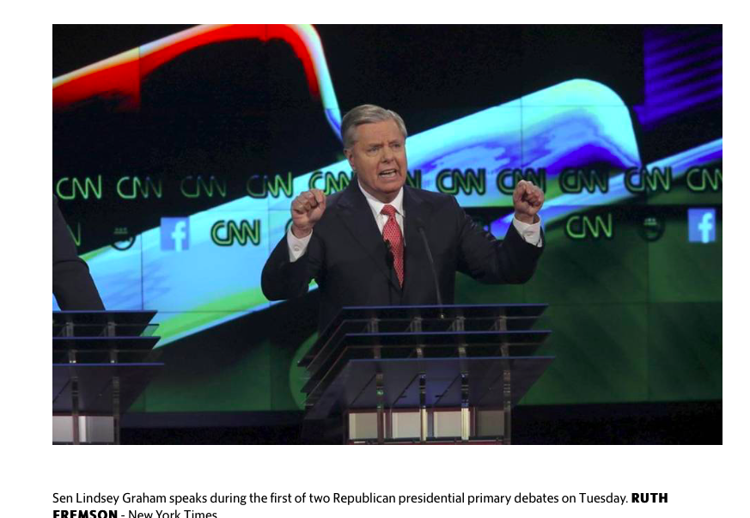

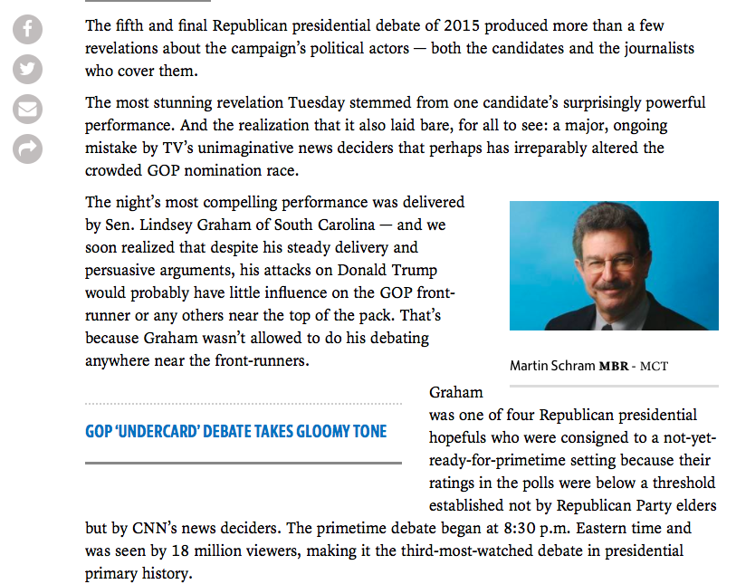

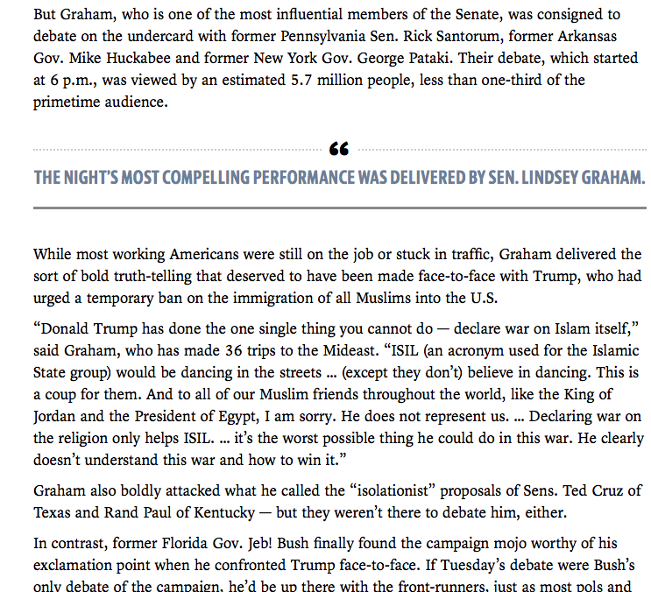

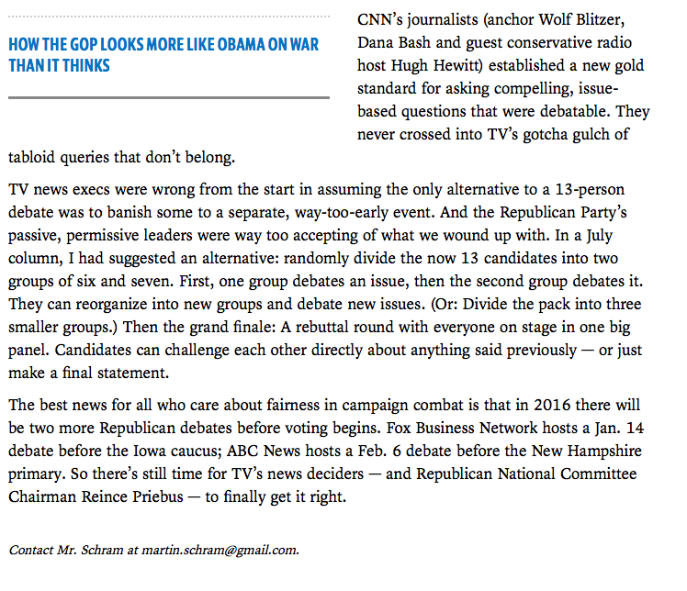

Schram, M. (2015, December 17). Martin Schram: Lindsey Graham's powerful debate performance most missed. Retrieved January 4, 2016, from http://www.thestate.com/opinion/op-ed/article50305345.html

National Review

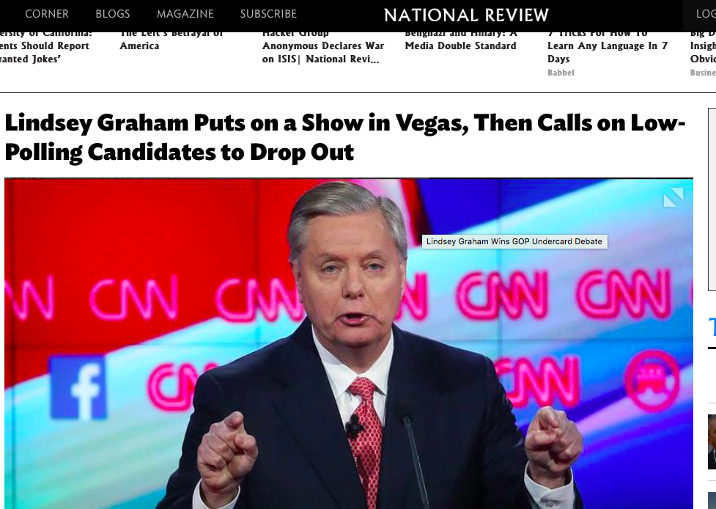

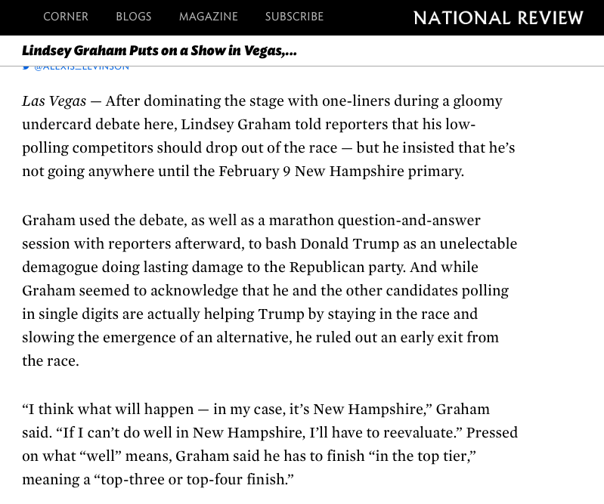

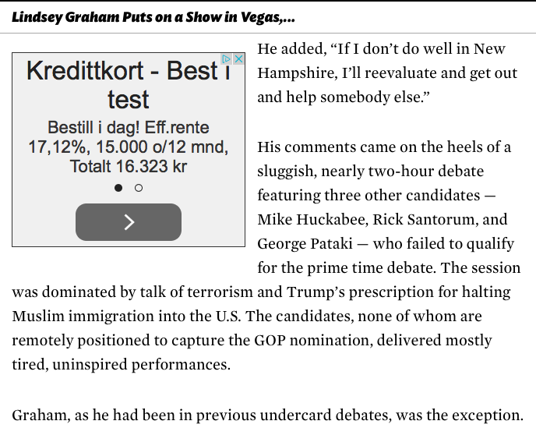

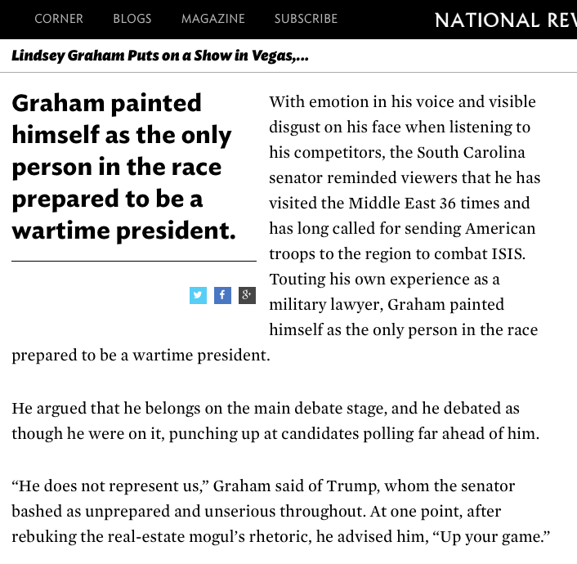

Alberta, T., & Levinson, A. (2015, December 15). Lindsey Graham Puts on a Show in Vegas, Then Calls on Low-Polling Candidates to Drop Out. Retrieved January 12, 2016, from http://www.nationalreview.com/article/428585/lindsey-graham-wins-gop-undercard-debate

