Digital media and Politics Imana Horbach
SNR - 2000048

The increase in popularity of Marine Le Pen’s Front National

Front National is often stigmatized as fascist by the media, because of their somewhat radical political ideas. However, Front National’s current leader Marine Le Pen is believed to have distanced itself from the party’s neo-fascist past. But according to an article by Mammone (2015), which was published in The Guardian, are these allegedly modern, non-extremist, far-right parties such as the Front National, in some ways, even more worrying than the old neo-fascists led by the likes of Jean-Marie Le Pen. Especially if we consider the current economic situation, the unpopularity of the EU, their own international networks and the recent links with Russia. But there is no doubt that since the rise of Marine Le Pen as new leader of Front National, the party has had an increase in popularity. But is this only the work of Marine Le Pen, or are there other contributing factors?

Electoral successes
Since Marine Le Pen took over the presidency of Front National from her father in 2011, she pursued a plan to expand the party’s base. Her tactics to do this are emphasizing economic themes, trying to recruit more credible candidates and focusing on local elections and winning greater representation in the European Parliament (Rubin, 2014). Her tactics seem to work, since at the 2014 municipal elections of France, provisional results showed that the Front National party set to take control of 11 town across the country. These results where a new record of Front National and easily beat the old record in the 1990’s, when Front National only ruled in four towns (Willsher, 2014). As stated by Willsher, voters wanted to punish president Hollandé, who was the president of France from 15th of May 2012 to 14th of May 2017, for his failure to turn around the Eurozone’s second largest economy, but more important, his failure to tackle the unemployment rate of more than 10% and at least 140 more towns swung from the left to mainstream opposition conservatives (2014). The most of Front National’s successes were in the west and east of the country, in areas with high unemployment and immigration. Thus, the moderating of the image of Front National under leading of Marine Le Pen and positioning the party to confiscate on widespread economic insecurity, deep anti-immigrant and anti-Muslim sentiment, and disgust with the political establishment, has helped Marine Le Pen gaining more voters and set a new record in the municipal election results.
But perhaps even more important, were the European Parliament elections of 2014 and the successes of Front National that came along with them. Only two months after the municipal elections followed the European Parliament elections. Front National received 24.9% of the vote in France in the European Parliament elections of 20th – 25th May 2014. With this amount of votes, Front National became the largest French party in the European Parliament with 24 seats (Page, 2014). The table below provides an overview of the results per region. In the table are the results of the first, second and third winning parties included:

Region | Front National | UMP | PS
North-West | 33.62% (5/10 seats) | 18.75% (2/10 seats) | 11.78% (1/10 seats)
West | 19.31% (2/9 seats) | 19.64% (3/10 seats) | 15.62% (2/10 seats)
East | 28.98% (4/9 seats) | 22.72% (3/9 seats) | 13.24% (0/9 seats)
Massif central-Centre | 24.18% (2/5 seats) | 21.38% (2/5 seats) | 15.82% (1/5 seats)
South-West | 24.71% (3/10 seats) | 18.52% (2/10 seats) | 15.73% (2/10 seats)
South-East | 28.18% (5/13 seats) | 22.40% (3/13 seats) | 11.88% (2/13 seats)
Ile-de-France | 17.00% (3/15 seats) | 21.79% (4/15 seats) | 14.28% (3/15 seats)
Overseas Territories | 10.25% (0/3 seats) | 26.70% (1/3 seats) | 19.36% (1/3 seats)
Figure 1, [Overview of the results of the 2014 French European Parliament elections]. Reprinted from “France’s Front National”, R. Page, 2014, International affairs and defence section.

As can be seen from the table above, Front National gained the most votes in almost every region. Front National only performed poorly in Ile-de-France and the Overseas Territories. This success can be, yet again, led back to the failing of the government. According to Haski (2014), has the economic and social crisis, with more than three million people unemployed and no concrete sign of aid, led to the conclusion of many French voters that the main parties have failed. French National has won the European Parliament elections with simplistic ideas. Ideas that are all radically different from the mainstream parties that tried, but still failed with “reasonable” policies. The map in figure 2 shows the voting percentage per region for Front National, the darker the shade, the higher the vote percentage. Figure 3 shows also map of France, but now with the unemployment percentage per region.
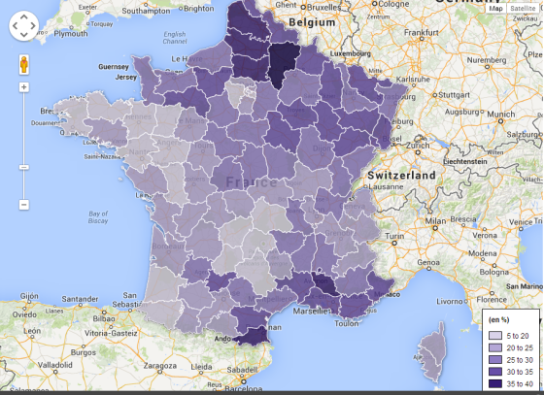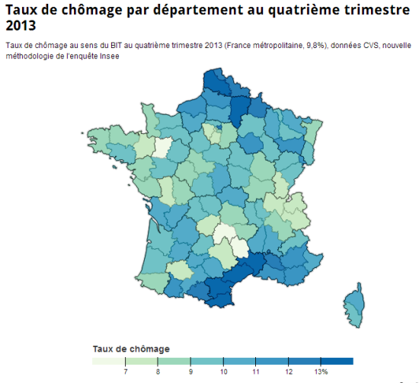
Figure 3, Unemployment by department Q4 2013. Reprinted from Prime Economics, by J. Smith, 2014
Figure 2, European Parl FN vote in 2014 election. Reprinted from Prime Economics, by J. Smith, 2014
Looking at both figures, we can indeed see a strong correlation between the regions that voted in favour of Marine Le Pen’s Front National in the 2014 European Parliament elections, and the regions with a high unemployment rate.

Xenophobia
On the 23th of April, 2017, French citizens shared their vote in the first round of the country’s presidential elections. Emmannuel Macron, now president of France, came out as first, with acquiring 24% of the votes. Right behind him came in Marine Le Pen as second, with 22% of the votes (Martin, 2017). A reason for these high numbers are that more and more millennials are supporting Front National. Millennials say that the recent terrorist attacks in France, referring to the 14th of July, 2016 in Nice and 13th of November, 2015 in Paris, and various attacks across Europe validate their personal views and the anti-immigration viewpoint of the party. Critics say Marine Le Pen’s platform is nourished by fear and xenophobia (Chadwick, 2016). Front national’s support among young voters has grown heavily. In the first round of the presidential election in 2007, gathered Front National 6% of the votes of 18-24 year olds, and in 2012 18% (Obs, 2012). And three years later, in the regional elections, 34% of 18-24 year olds voted for Front National (Anonymous, 2015). According to Martin (2017), are the challenges that the young generation in France face, in particular economic and social problems, a key part of understanding the support of Front National by the youth. Marine Le Pen’s anti-Enlightment ideology, she speaks in a very nationalistic and anti-universal way and preaches for inequality, helps her portray herself and her party Front National as fighting for French sovereignty against an occupying European Union. Marine Le Pen seems to care more for the French people, than for the immigrants. Therefore, youth who feels insecure and want to see changes that are triggered by the recent terrorist attacks, can see in Marine Le Pen an attractive leader.

Conclusion
Since Marine Le Pen took over the presidency of Front National from her father, she has portrayed a new, de-radicalized image of her party. This to attract more supporters and to withdraw from the parties neo-fascist past. This new approach seems to have worked, because since the presidency of Marine Le Pen, Front National has had some important electoral winnings, new electoral records and an increase in supporters. But these successes are not all due to Marine Le Pen. While Marine Le Pen portrays a new image and makes use of messages such as: “Au nom de people”, which translates to “In the name of the people”, to attract more voters and supporters, there are other contributing factors explaining the newly gained popularity of Marine Le Pen’s Front National. The failure of the former president Hollandé, in matters such as the high unemployment rate, made sure that a lot of people in France were sick of the situation and wanted to have a drastically change in politics. Marine Le Pen made Front National less fascist, and therefore more accessible for the average people, but still maintained the core foundation of Front National with its radical politics and simplistic ideas. Thus, Front National’s electoral successes can be lead back to the new more open image Marine Le Pen has given to Front National. But perhaps more important and even more reliable, can be lead back to the failure of the government. A failure, that lead to people wanting a drastic and radical change in politics. A change that Front National can provide better than the left winged parties.
Xenophobia is also a reason for the increase in popularity of Front National. Recent terrorist attacks, was a reason for a lot of young French citizens to vote for Marine Le Pen and her party. Her anti-Enlightment ideology, which includes an anti-immigrant viewpoint, helped her gaining support from youth, who want to drastically change the French politics regarding these issues.
Thus, while Marine Le Pen softened her party’s image and turned her back on the party’s neo-fascist past in order to gain more support, there were other contributing factors helping Front National in their increase in popularity. The unemployment rate and the recent terrorist attacks are the most important factors. People who vote for Front National want drastic changes in France regarding these factors. Since previous political party’s, with less radical views, have failed in changing France, people are now voting for Front National. According to many voters is Front National, with Marine Le Pen as their leader, the change France desperately needs.
References
Anonymous (2015) Régionales 2015: 34% des jeunes ont vote Front national. 20Minutes. http://www.20minutes.fr/elections/1745291-20151207-regionales-2015-34-jeunes-vote-front-national
Chadwick, L. (2016) France’s National Front Finds Support Among Millennials. NBC News. https://www.nbcnews.com/news/world/france-s-national-front-finds-support-among-millennials-n697681
Haski, P. (2014) The front National’s vitory reflects a failure of France’s elite. The Guardian. https://www.theguardian.com/commentisfree/2014/may/28/front-national-victory-failure-of-frances-elite
Mammone, A. (2015) Don’t be fooled by ‘moderate’ Marine Le Pen. Front National’s more toxic than ever. The Guardian. https://www.theguardian.com/commentisfree/2015/apr/10/dont-be-fooled-by-marine-le-pen-front-national-toxic
Martin, V. (2017) France’s Front National and millennials: when insecurity and fear meet social media. The Conversation.
https://theconversation.com/frances-front-national-and-millennials-when-insecurity-and-fear-meet-social-media-76377
Obs (2012) Ces jeunes qui ont rejoint le Front national. L’OBS. https://tempsreel.nouvelobs.com/politique/election-presidentielle-2012/20120424.OBS7055/ces-jeunes-qui-ont-rejoint-le-front-national.html
Page, R. (2014) France’s Front National (FN). Section International affairs and Defence Section.
Rubin, A. (2014) National Front Wins Support and Elections. NY Times. https://www.nytimes.com/2014/04/02/world/europe/moderation-pays-off-for-a-far-right-party-in-france.html
Smith, J. (2014) Mapping France – the link between unemployment, GDP and voting Front National. http://www.primeeconomics.org/articles/mapping-france-the-link-between-unemployment-gdp-and-voting-front-national?rq=Mapping%20France%20-%20the%20link%20between%20unemployment%2C%20GDP%20and%20voting%20Front%20National%22%2C
Willsher, K. (2014) French Socialists suffer as far-right and conservatives sweep elections. The Guardian.
https://www.theguardian.com/world/2014/mar/30/anne-hidalgo-socialist-first-paris-mayor-front-national

